PETER DUNNE REPORTS, NO 2, 2007

NEW ELECTORATE BOUNDARIES FINALISED SOON
New electorate boundaries for the 2008 and 2011 General Elections are due to be announced at the end of September. This follows the five yearly review of boundaries after last year’s census. Under preliminary proposals released earlier in the year, the Ohariu Belmont electorate is to lose the Belmont area to neighbouring Rimutaka, and pick up the Crofton Downs and Chartwell areas from Wellington Central. As a consequence, the electorate is to be renamed Ohariu, the name of the electorate that I represented from 1984 to 1993. The change to Ohariu Belmont has been brought about because Wellington Central is over its population quota and has to shrink in size, while Rimutaka is under population quota and has to increase. Once the new boundaries are announced they apply from the next election, which means that I will continue to represent Belmont until that time.

NEW CHURTON PARK SCHOOL GETS GO AHEAD
The recent announcement buy the Minister of Education that a new school is to be built in Churton Park is good news indeed. It follows a very successful campaign by the local group, Campaign for Local Schools, led by Roger Ellis, and I congratulate him on their success. Many details about the new school have yet to be finalised, and discussions between the Ministry of Education and the local community will need to take place soon to start this process. In the meantime, the successful outcome to the campaign shows just what a well led and hard-working local group can achieve, and I was very pleased to have been able to work with Roger and his team to get to this point.

OUT WITH THE VODAFONE WELLINGTON LIONS
Vodafone recently hosted an event for young supporters of the Wellington Lions Rugby team to meet their heroes. Harry Milner and Emma Berryman from Johnsonville Main School joined me for the occasion. (Add Picture LLL_4074.jpg)

YOUTH PARLIAMENT AN OUTSTANDING SUCCESS
The Youth Parliament held at the beginning of July was an outstanding success, with an impressive display of the country’s future leaders. As Ohariu Belmont’s Youth MP, Hutt Valley High School’s Amanda Hillock performed strongly, both in the select committee meetings and in the Parliamentary debate. She also featured as a special guest on Newstalk ZB’s “Face Off” programme.

MADE IN NEW ZEALAND: KIWI PARENTS
UnitedFuture has just launched “Made in New Zealand: Kiwi Parents”, a substantial discussion paper covering a range of issues affecting New Zealand parents today, and inviting feedback from those who are interested, to assist us in policy formation. The document has been well received by many community groups and parents, with a number organising discussion meetings around its themes. If you would like a copy of the document, please contact my office, or download a copy from our website www.unitedfuture.org.nz.

DOWSE DRIVE INTERCHANGE UNDERWAY
Recently I helped Transport Minister Annette King turn the first sod for the development of the new Dowse Drive interchange on State Highway 2. This is an important development which will improve access to the Western Hills, and should be seen as the first stage of a major redevelopment of transport links across the Hutt Valley. At the same time, it seems clear that the need for the proposed Horokiwi to Petone link road is becoming more questionable, given both likely route problems, and also the increasing prospect of Transmission Gully highway making this link road redundant. I would be more than happy to see the $180 million sum estimated as the cost of the Horokiwi to Petone link road dedicated to the Transmission Gully project.

WAIRERE/POMARE ROADS UPGRADE BEGINS
Work is also underway on improvements to the intersection of Wairere and Pomare roads with State Highway 2, following intense discussions between local residents and Transit New Zealand at two well-attended public meeting in November and March. I am continuing to monitor this issue and have undertaken to convene another public meeting later in the year if concerns remain.

WELCOMING DALAI LAMA TO PARLIAMENT
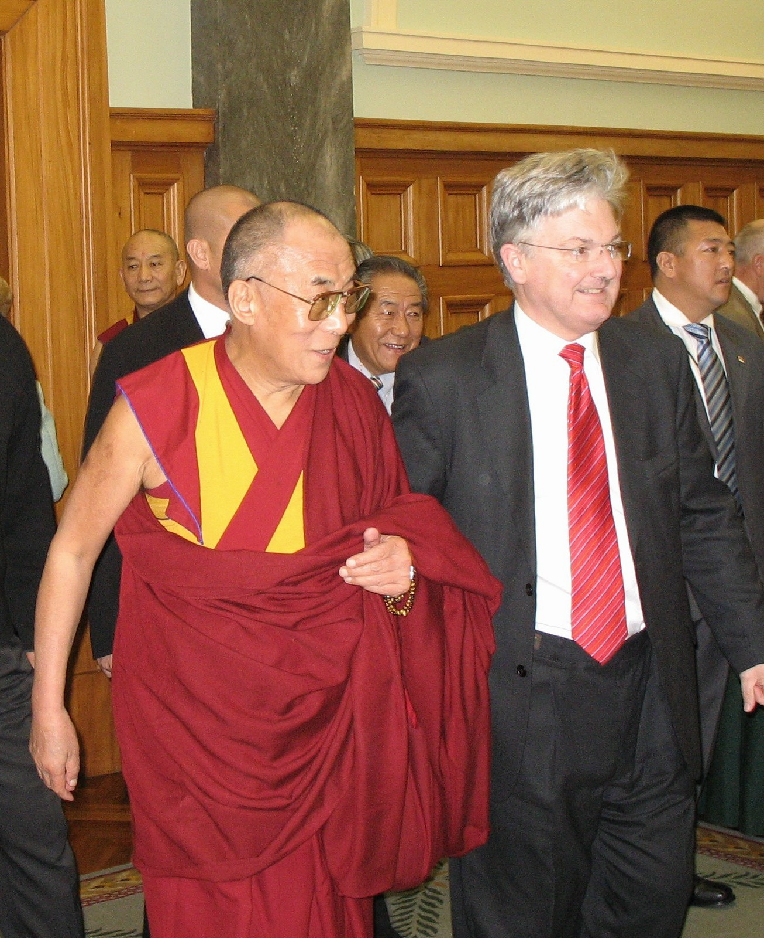
It was my great privilege, on behalf of the National Press Club, to host His Holiness the Dalai Lama during his recent visit to Parliament. He is a significant world leader, and I was saddened that the New Zealand government failed to recognise this and accord him the usual formalities, simply out of fear of upsetting China. In the absence of the usual official courtesies, I was more than happy to welcome him to Parliament.

2007 NORTH WELLINGTON VOLUNTARY SERVICE AWARDS PRESENTED
North Wellington Voluntary Service Awards have been made to ten local community volunteers. The 2007 Awards were presented by Community and Voluntary Sector Minister Luamanuvao Winnie Laban at a special dinner in Johnsonville recently. The Awards were established following the International Year of the Volunteer in 2001 to celebrate the contribution of local volunteers, with approximately 60 Awards having been made since then. Between them this year’s recipients have dedicated almost 200 years of voluntary service to our local community. As chair of the North Wellington Voluntary Service Awards committee I want to express my congratulations to this year’s recipients and my acknowledgement to all community volunteers for the important and unsung work which they do.

UNITED FUTURE LAUNCHES NEW WEBSITE
UnitedFuture has a new logo and more interactive website, www.unitedfuture.org.nz, where all our statements and policies are on display, and with a full range of blogs, and interactive forums and surveys. We have also adopted a new mission statement, setting out clearly our position as a modern centre party, focused on New Zealand's best interests. We promote strong families and vibrant communities. We seek a fair, and open society, free from poverty, ignorance and prejudice, and based on innovation, self-reliance, justice and integrity in business and personal dealings. We promote a sustainable environment, and a competitive economy which encourages growth, prosperity, ownership and opportunity through market policies where possible, and government where necessary. We want all New Zealanders, whatever their background, race or creed, to have the chance to enjoy everything that is good in our country.

ELECTORATE OFFICE DETAILS
My two electorate offices are deal with a full range of constituent enquiries. Shirley Simcock operates the Johnsonville Office at the Johnsonville Community Centre, 3 Frankmoore Avenue, Johnsonville. It is open Monday to Thursday from 9:00 am to 3:00 pm, phone 478 0076, or email at electjville@xtra.co.nz. The regular JPs Clinic where local Justices of the Peace are available each weekday to sign documents etc is proving very popular. More details can be obtained from the Johnsonville office. Sue Locke runs the Lower Hutt office at 66-70 Bloomfield Terrace, Lower Hutt. It is open on Mondays and from Wednesday to Friday from 9:00 am to 3:00 pm. The phone number is 560 4773, and the email address is huttelectorate@xtra.co.nz. You can contact either office to make an appointment to see me on a Monday morning, or at one of my regular Saturday clinics in either Johnsonville, Newlands, Tawa or Lower Hutt.

